Lesson 1- Objective: Determine how AI tools can be used for current HR processes.

AI tools can improve many processes that are in place today in corporate environments by taking mundane work away from employees, freeing them to do more complex work.

Employee performance can be monitored and personalized training plans can be created to fill individual skill gaps and provide paths to professional development.

Security issues, fraud and abuse are more easily detected, and errors can be eliminated resulting in money savings and improved customer satisfaction.

Instruction | Working Space
How can HR use:
Deep Learning
Face Recognition
Chat Bot
Chat GPT
Voice Recognition
Select the links below and then choose two of them and write/type in the space to the right give an example of how they can be used for current HR processes. Feel free to use your imagination! Then post your idea in the discussion section.

- Open AI
- Mathworks
- Otter.ai
- Amazon Rekognition

Lesson 2- Determine how bias can impact AI tools used for HR management and content development.
One large area of concern with the introduction of AI is unconscious biases in algorithms. As HR professionals, you need to be aware of how biases in algorithms can make decisions that are not always correct. Below, reflect on your thoughts of this bias as related to your work.
How could implicit bias in AI tools effect the work that you do in HR or learning and development?
What were the results of your bias test? Did this surprise you, why or why not?

Lesson 3- Determine how having guiding principles for the use of AI can uphold human value and diminish harmful consequences.
Guiding principles are your North Star. Decision making is made easier if principles are in place that keep your focus on goals, mission and vision no matter what is at stake. It makes sense then that there should be guiding principles for responsible use of AI. We are at the forefront of a new technology that is making a huge impact on the world therefore creating a framework is important for security, ethical use, human dignity, autonomy and the list goes on and on. Factors that must be considered are not at the tip of the iceberg but at the very top of the iceberg. We don’t know what we don’t know. Above all, what we should be considering is how to maintain respect and uphold human values and at the same time diminish harmful consequences that could be created by AI.
Use the image below to create guiding principles for use of AI elements you learned about in Lesson 1. You may also download the image from the Resources tab.
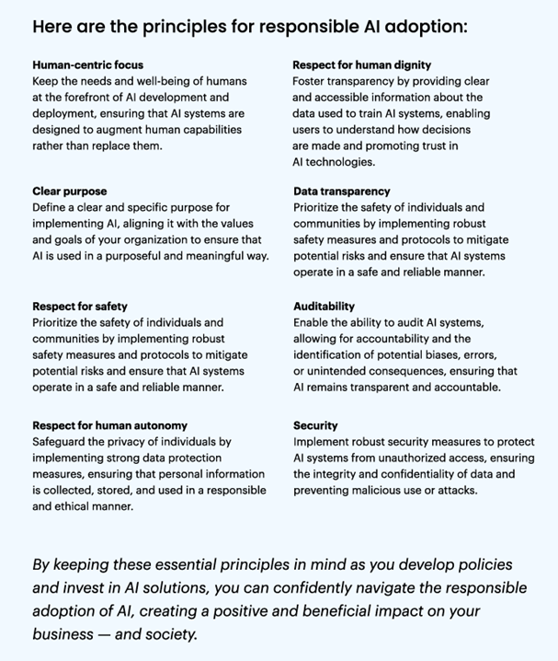
AI Elements: | Your guiding principles:
Deep learning
Generative chat/ Machine learning
Chat Bot
Face recognition
Speech recognition

Lesson 4
In the space provided in your workbook on pages 4-5:
- Choose 4 principles of responsible use from the AI principles chart in lesson 3.
- Determine a specific AI tool you want to create your framework around.
- Define your responsible use in terms of your AI tool.
- Create a graphic that depicts your principles.
- Add your definitions of responsible use somewhere near the graphic so it is known they go together.
You may download the table from lesson 3 and this graphic from the resources tab at the top of the page. You may scan your image to link or create something in any software you would like to use. Share your link to your graphic or embed the graphic in the discussion section to recieve and provide feedback to others.
Your element: | Define principles for your element here.
Provide your graphic here:

